* Members:

- Nguyễn Đăng Trung

- Nguyễn Hoài Nam

- Phùng Gia Huy

- Nguyễn Xuân Vinh

- Bùi Hồng Sơn

- Hoàng Đức Nghĩa

**Report**

Project idea: School management

*(We will focus on management in University)*

**I. Problem statement & Requirements**

*1. Problem statement:* Each school has much information to input, output, process, save,… => We need something to manage them effectively.

*2. Requirements:*

- Input data:

+ Basic information from students and teachers.

+ Attendance checking of both students and teachers

+ Tuition checking.

+ Points of students through each semester.

+ Timetable.

- SQL application

**II. ER diagram**

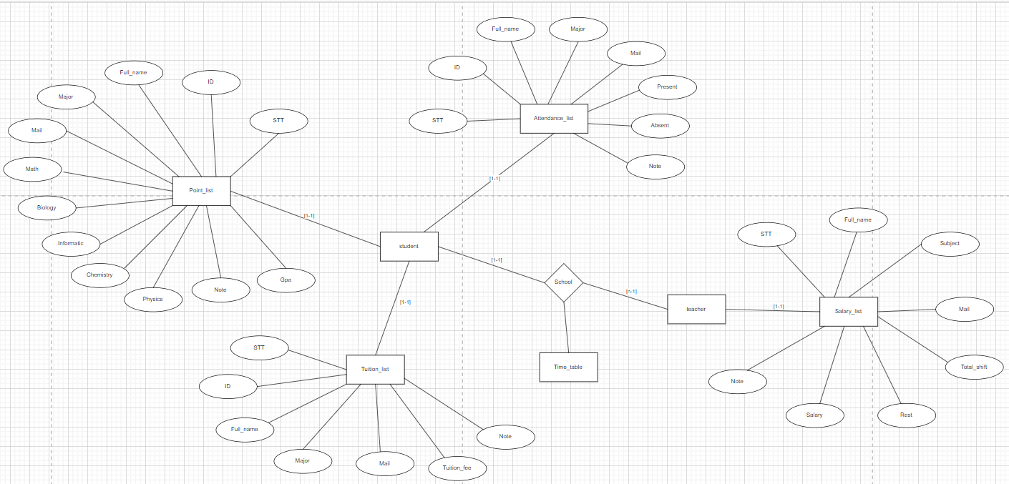

**III. Database design**

*1. Database for teachers*

- **Firstly**, we create a main table for teachers and insert some basic values (input basic information of teachers)

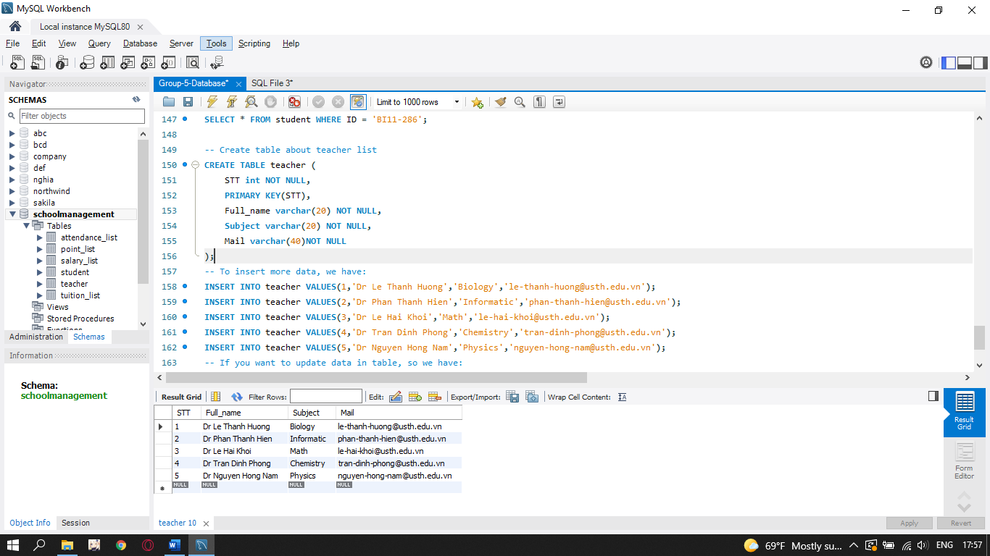

+ Set STT as primary key for a table enforces the table to accept unique data for a specific column and this constraint creates a unique index for accessing the table faster.

+ Set STT, Full_name, Subject, Mail as NOT NULL allows to specify that a column can not contain any NULL value.

+ If you want to update some values in the table like we change the subject of Dr. Nguyen Hong Nam from Physics to Philosophy:

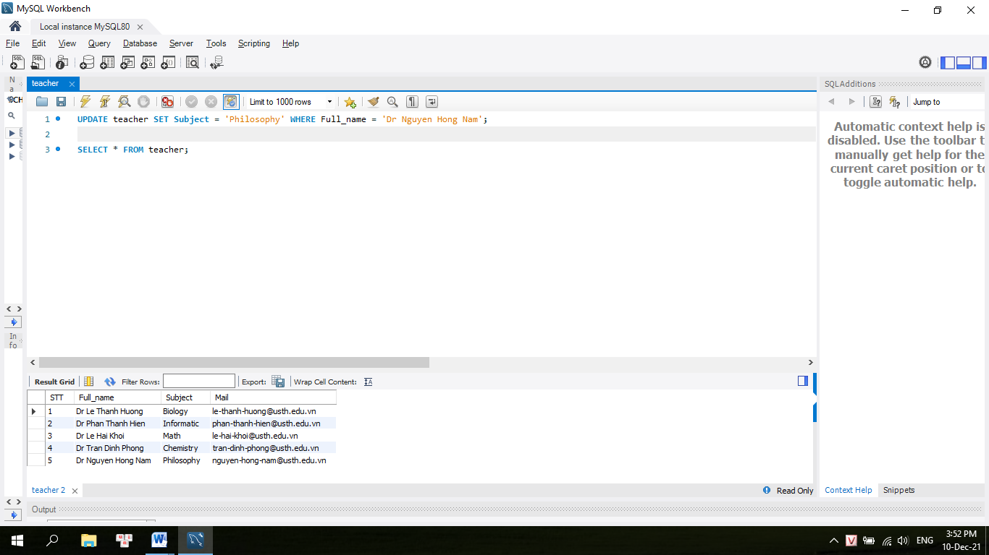

+ Delete some values in the table:

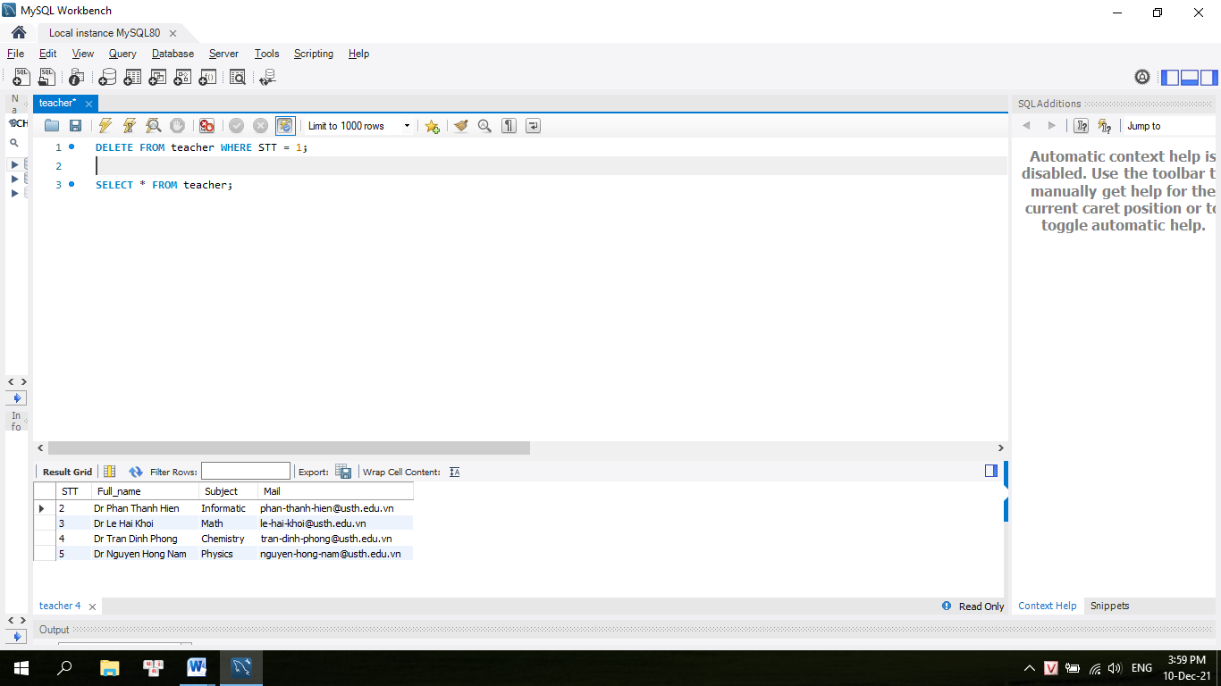

+ Show all the data from the table:

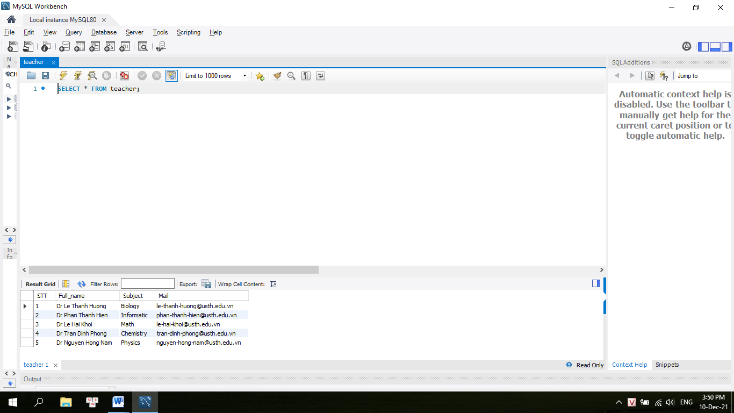

+ If you just know a little information about someone, and you want to know all the information, like you just now the subject, we have an example:

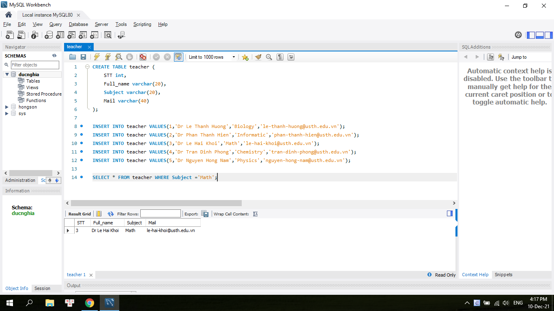

- **Secondly**, we have a table to check number of shifts per month to calculate the salary respectively for teachers:

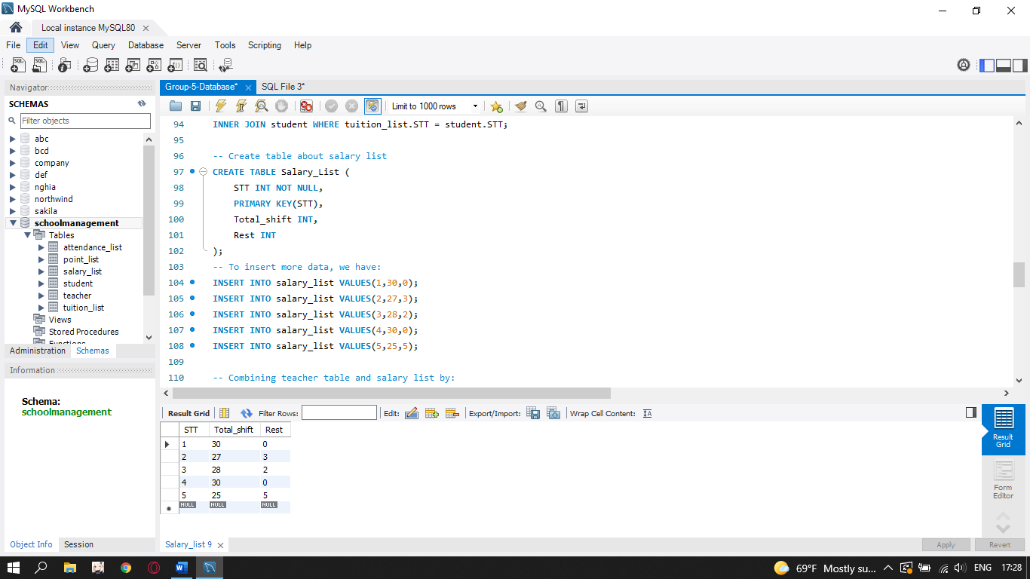

+ Set STT as primary key for a table enforces the table to accept unique data for a specific column and this constraint creates a unique index for accessing the table faster.

+ Set STT as NOT NULL allows to specify that a column can not contain any NULL value.

+ If we want to delete 1 kind of data, we have an example:

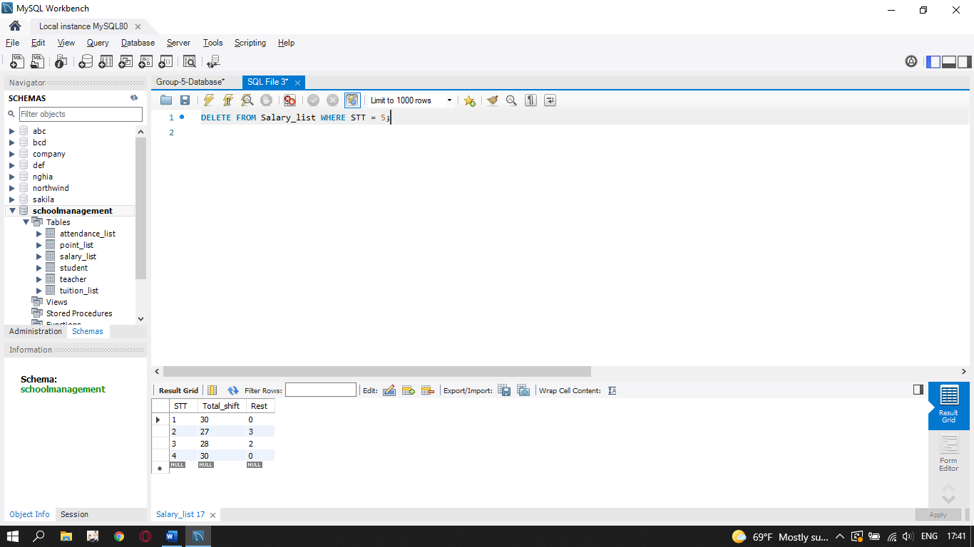

+ If you want to update data in table, we have an example:

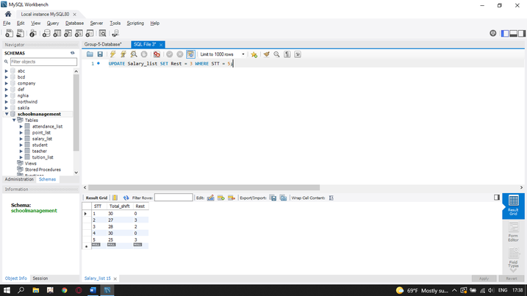

+ Order data from the first to the last by:

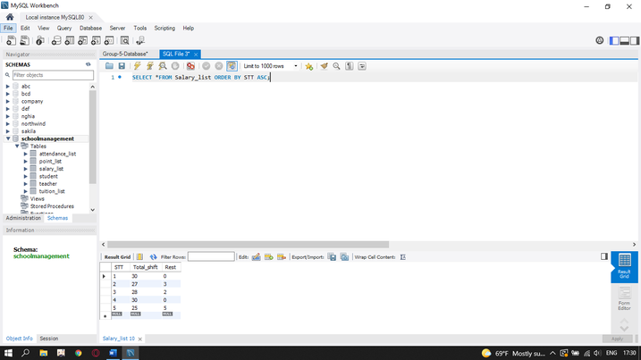

+To calculate the salary, we have:

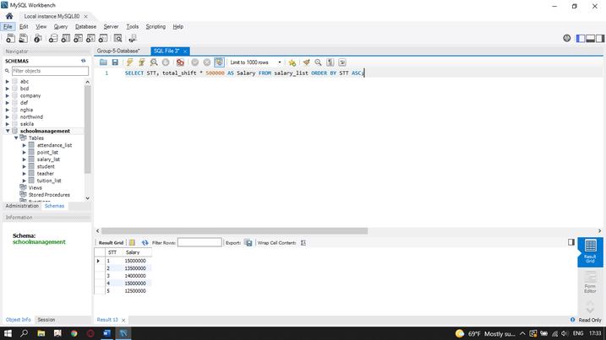

+We combine the salary list with the teacher table:

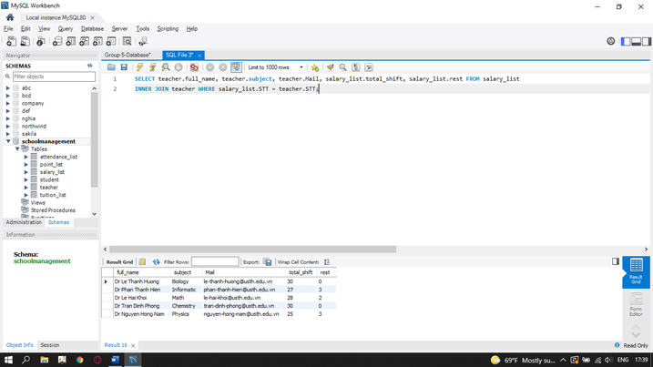

*2. Database for students*

- **Firstly**, we create a main table for students and insert some basic values (input basic information of students)

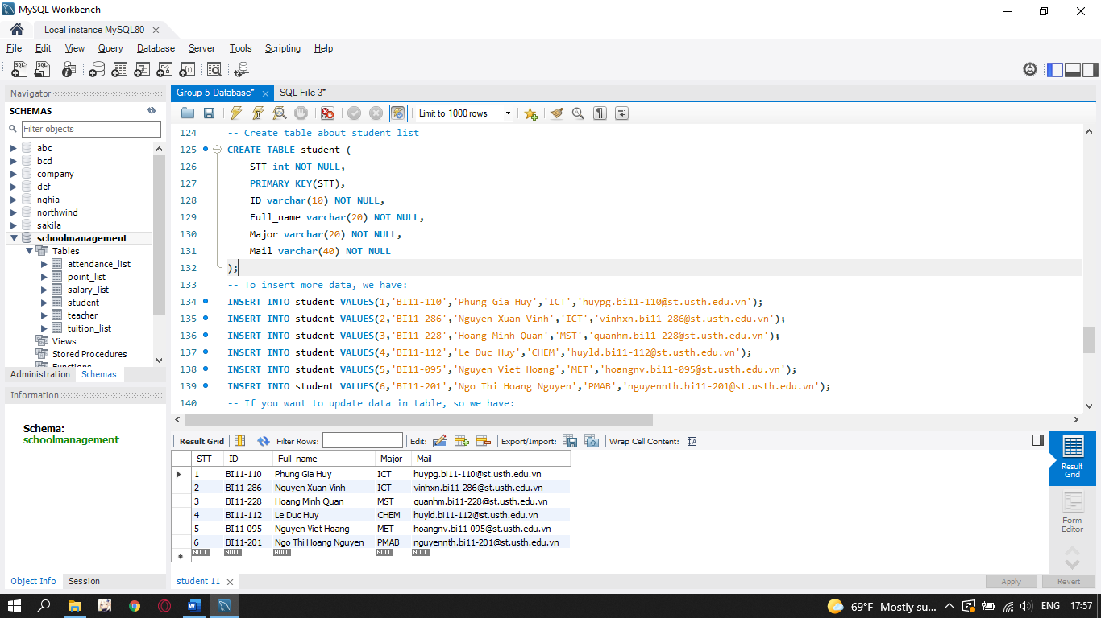

+ Set STT as primary key for a table enforces the table to accept unique data for a specific column and this constraint creates a unique index for accessing the table faster.

+ Set STT, ID, Full_name, Major, Mail as NOT NULL allows to specify that a column can not contain any NULL value.

+ To update data in the table, we have an example:

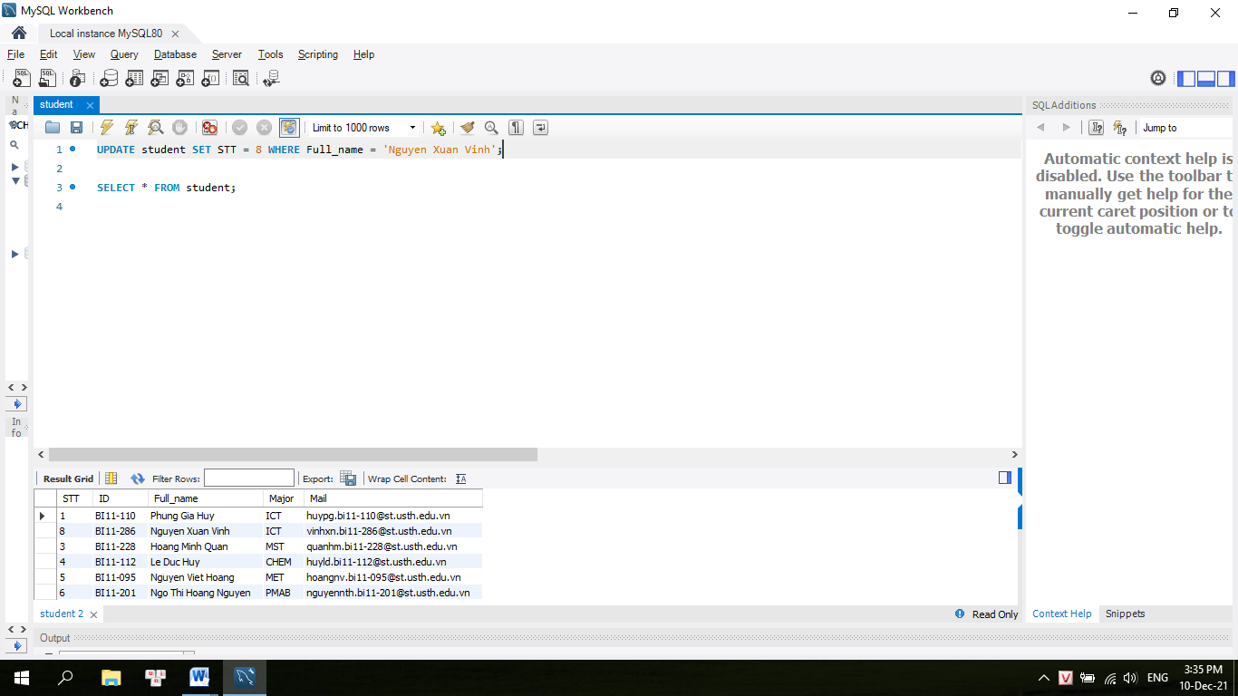

+ To delete some values in the table, we have an example:

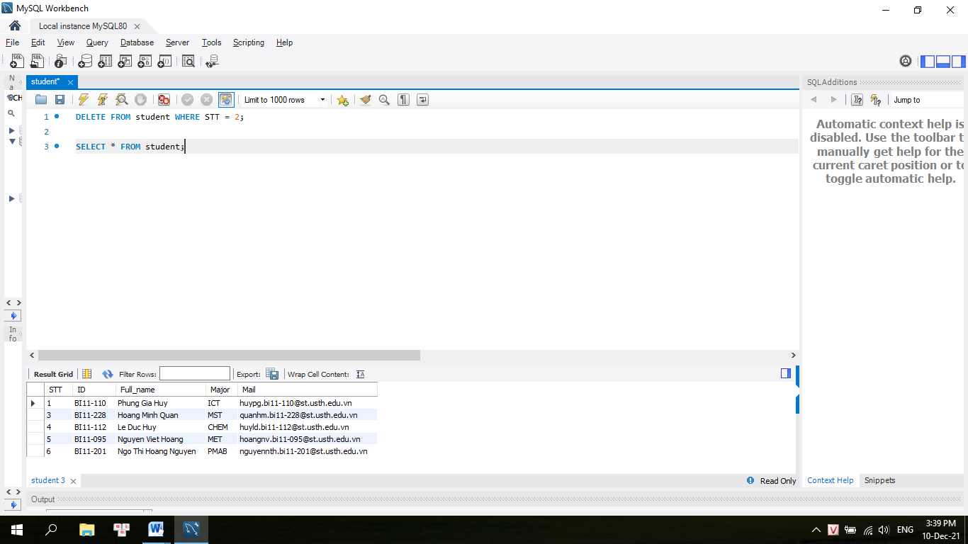

+ To show all data from the table:

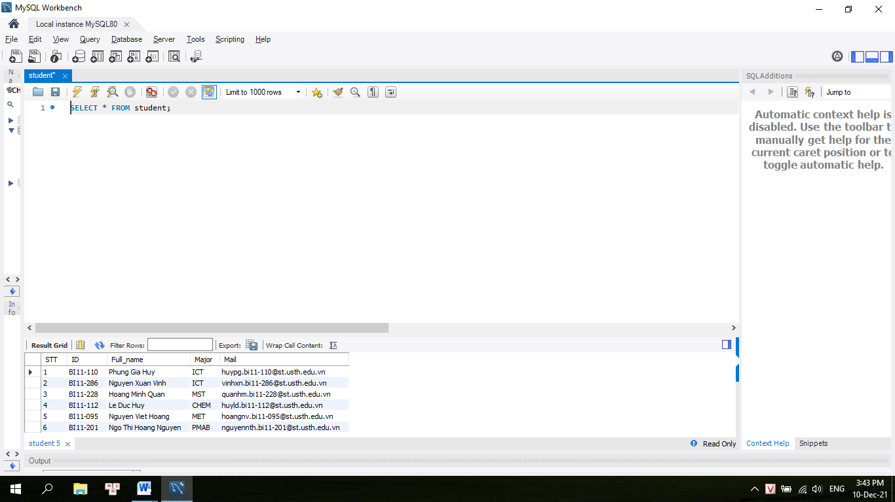

+ If you just know a little information about someone, and you want to know all the information, like you just now the subject, we have an example:

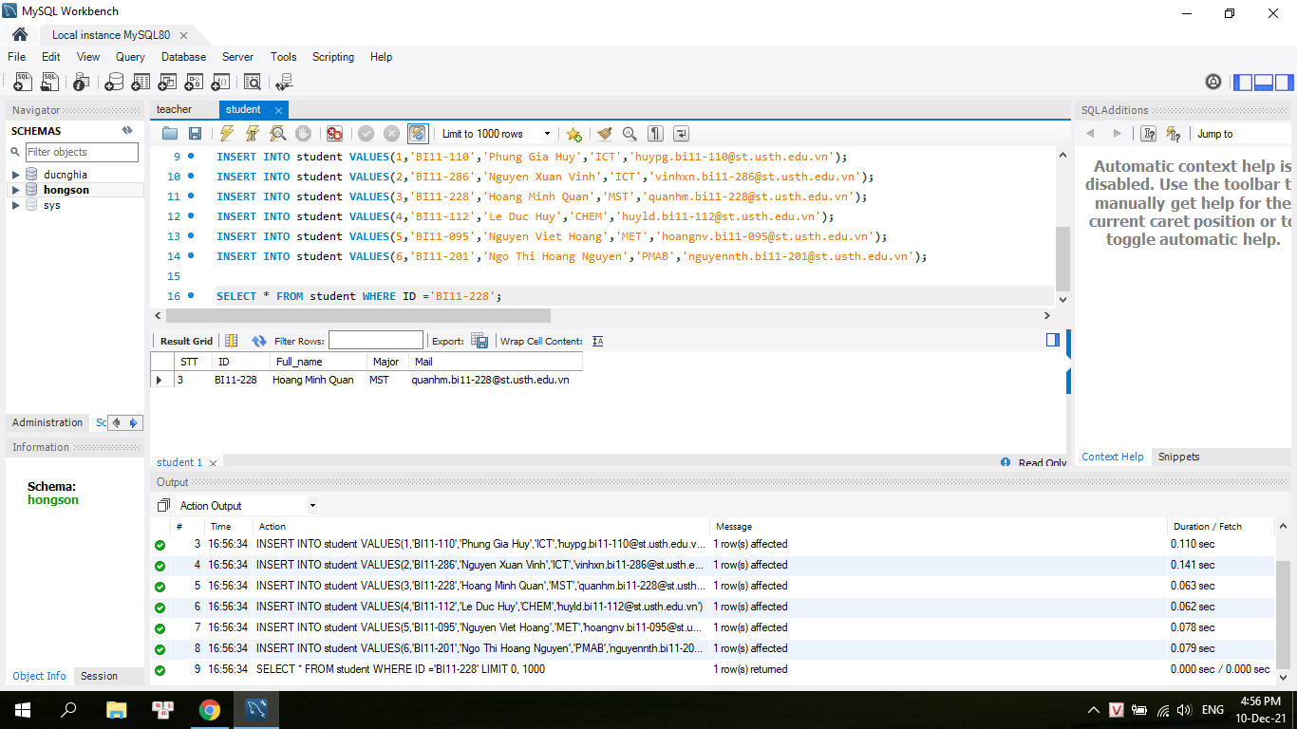

- **Secondly**, we create a table to input points of students to set point list for students. We have an example for inputting points of 5 subjects of one semester:

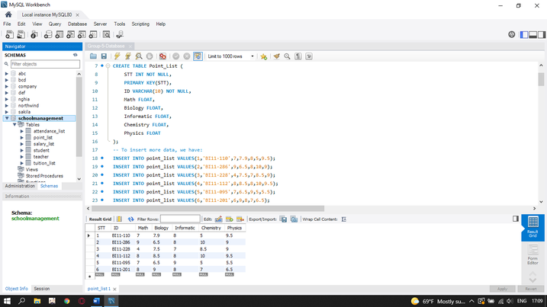

+ Set STT as primary key for a table enforces the table to accept unique data for a specific column and this constraint creates a unique index for accessing the table faster.

+ Set STT, ID as NOT NULL allows to specify that a column can not contain any NULL value.

+ If we want to delete 1 kind of data, we have an example:

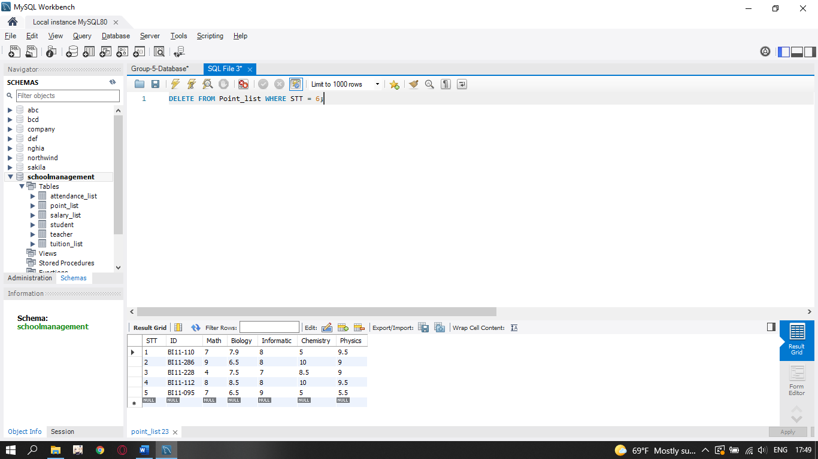

+ If you want to update data in the table, we have an example:



+ Order the data from the first to the last by STT

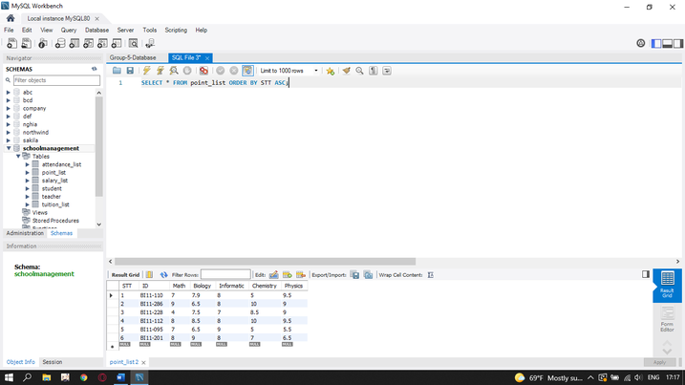

+ If you want to calculate the Gpa depends on these 5 subjects, and you want to order the list of students by Gpa points, from lowest to highest, we have an example:

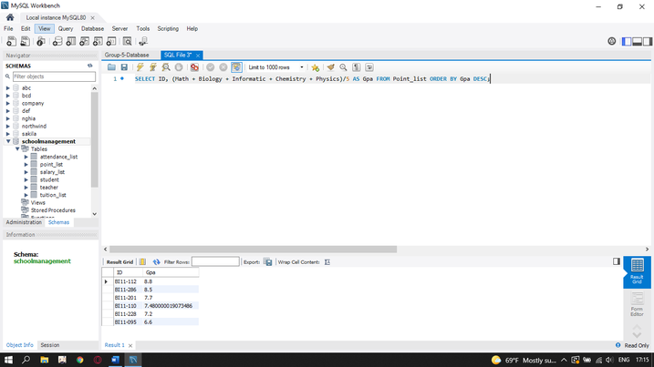

=> We can depend on that to set scholarship for students or we can know students who get low marks must have retake exams or redo the course.

-We combine the point list to the student list:

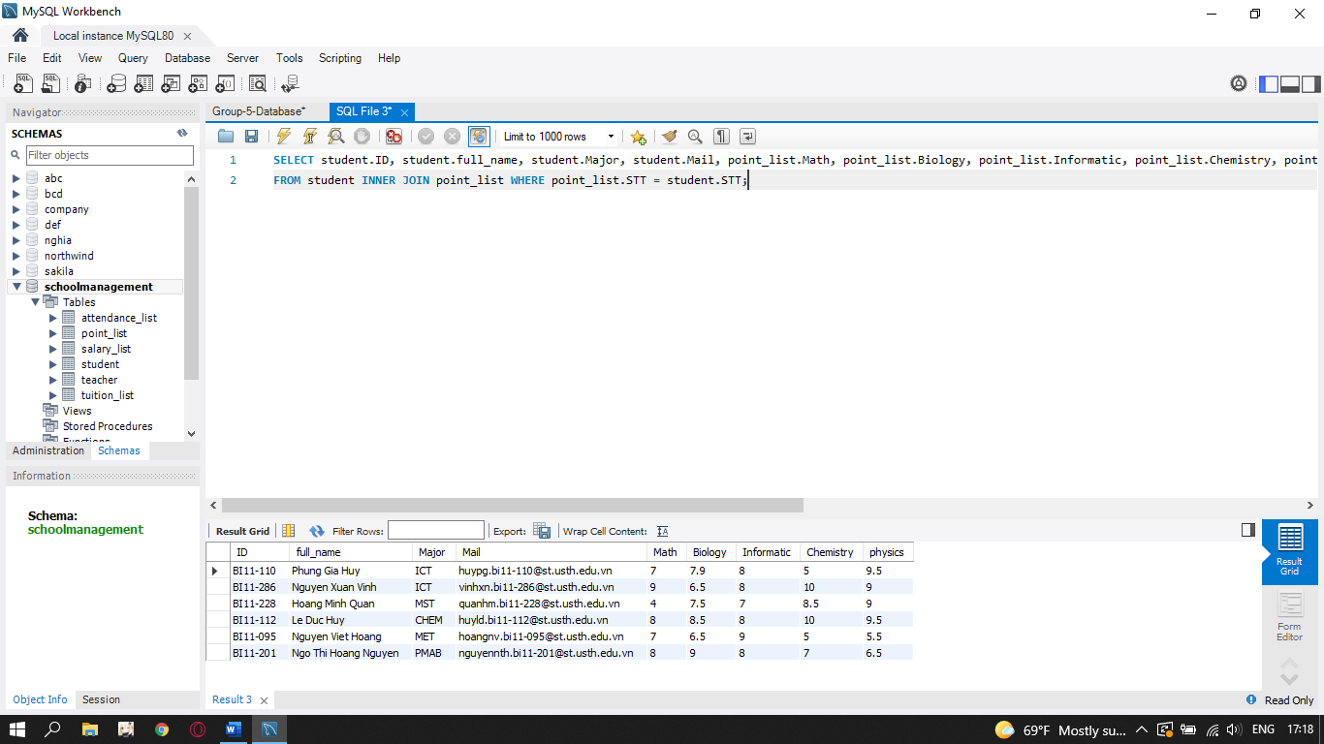

**Thirdly**, we create a table to check attendance for students and insert some data, like example:

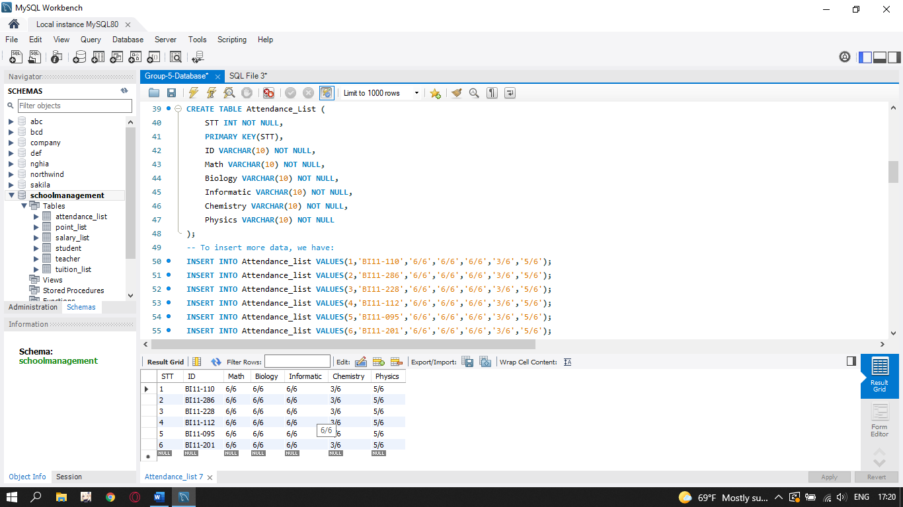

+ Set STT as primary key for a table enforces the table to accept unique data for a specific column and this constraint creates a unique index for accessing the table faster.

+ Set STT, ID, Math, Biology, Informatic, Chemistry, Physics as NOT NULL allows to specify that a column can not contain any NULL value.

+ If we want to delete 1 kind of data, we have an example:

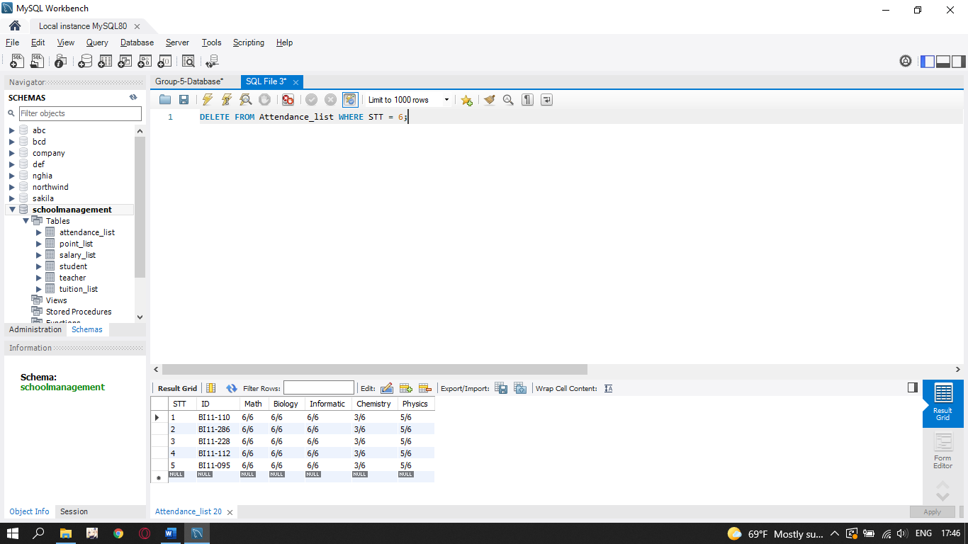

+ If we want to update the data in the table, we have an example:

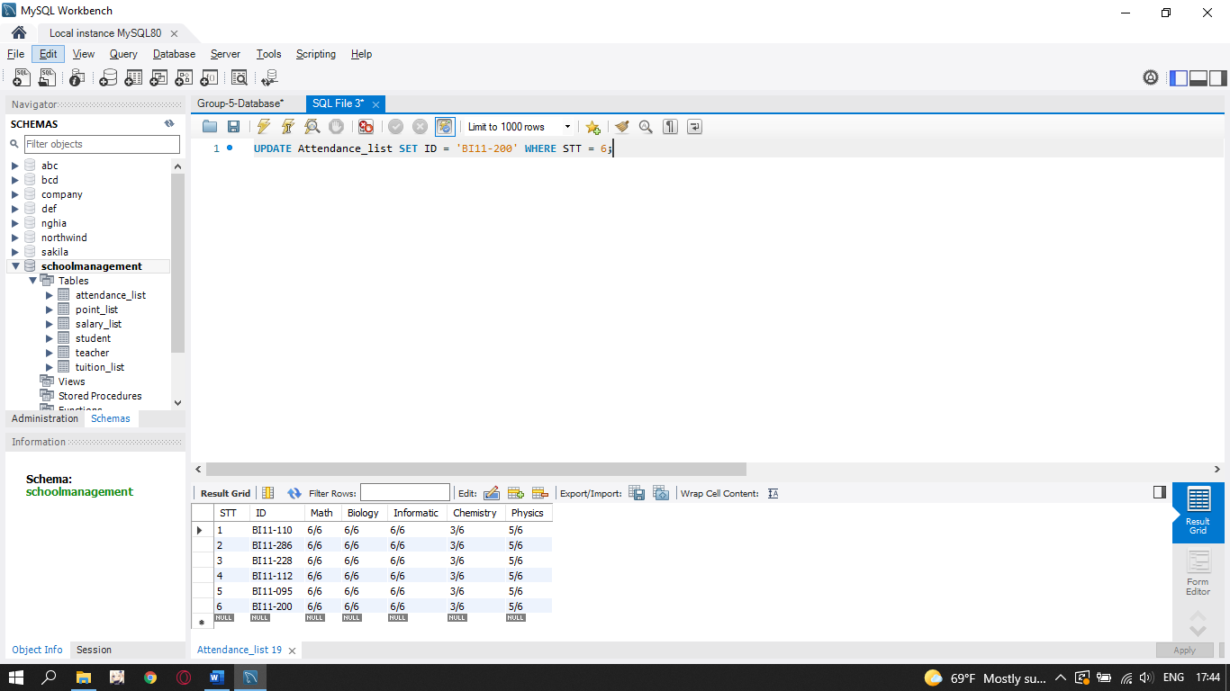

+ Order the data from the first to the last by:

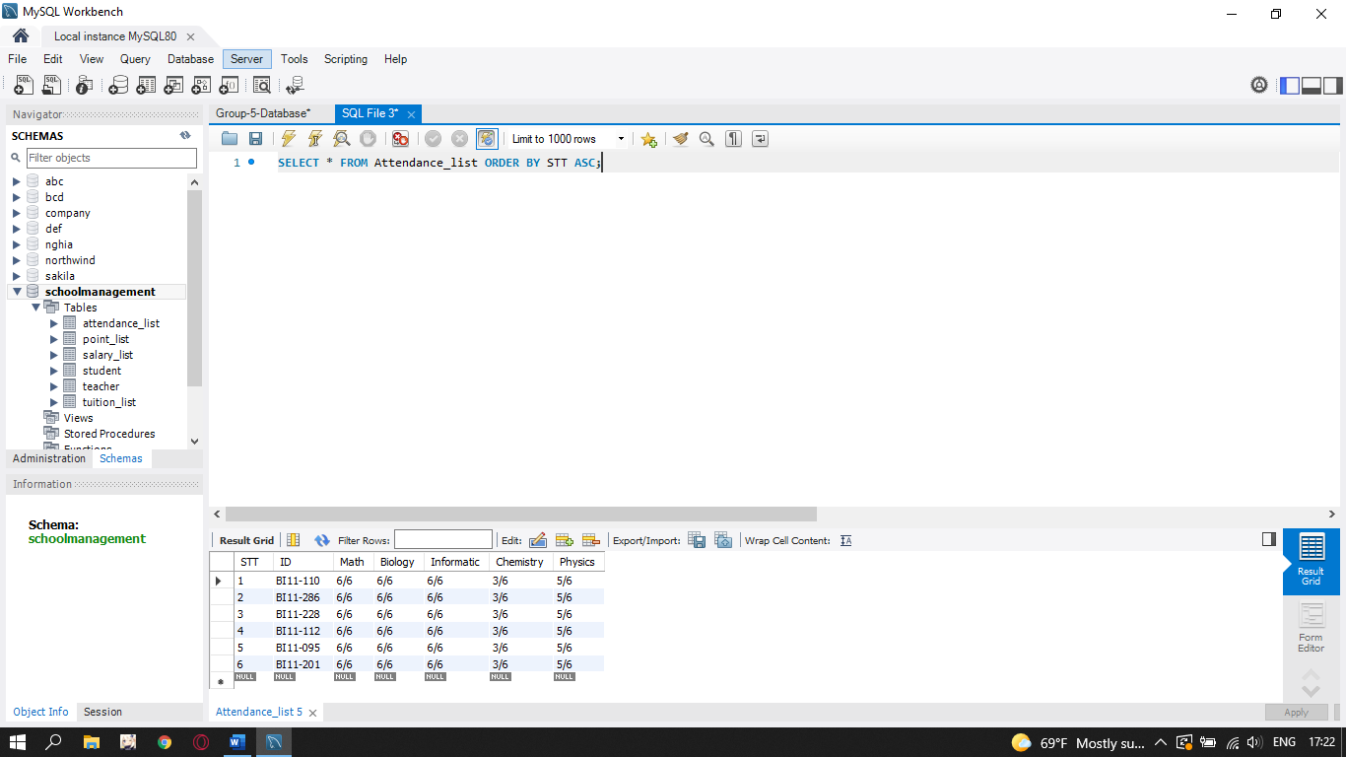

-Finally, we combine the attendance list and the students list:

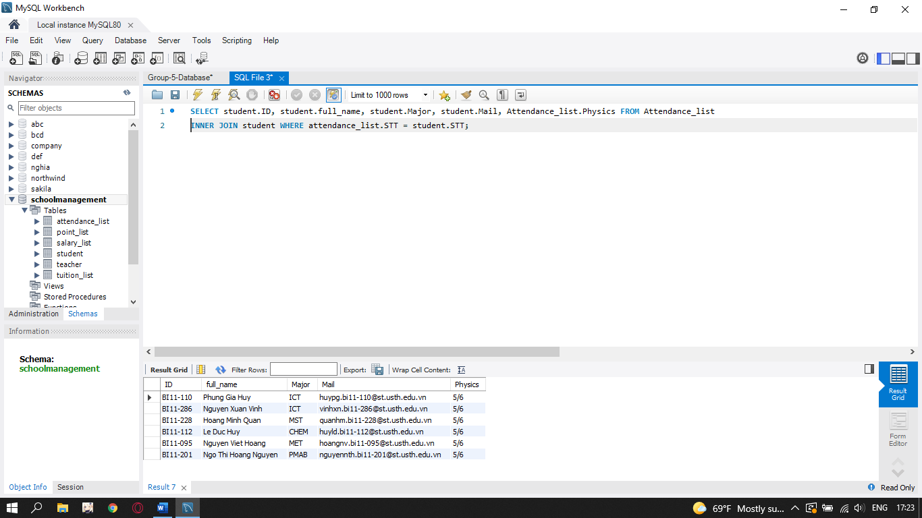

- **Fourthly**, we create a table to check tuition fees per semester for students, how much each students and insert some information:

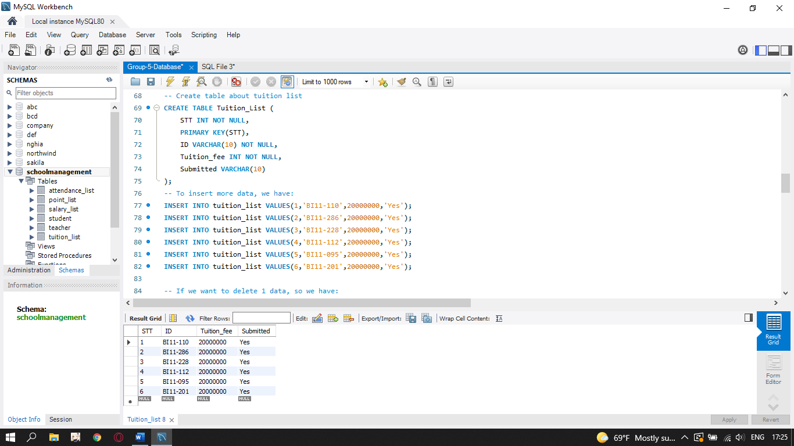

+ Set STT as primary key for a table enforces the table to accept unique data for a specific column and this constraint creates a unique index for accessing the table faster.

+ Set STT, ID, Tuition_fee as NOT NULL allows to specify that a column can not contain any NULL value.

+ If we want to delete 1 kind of data, we have an example: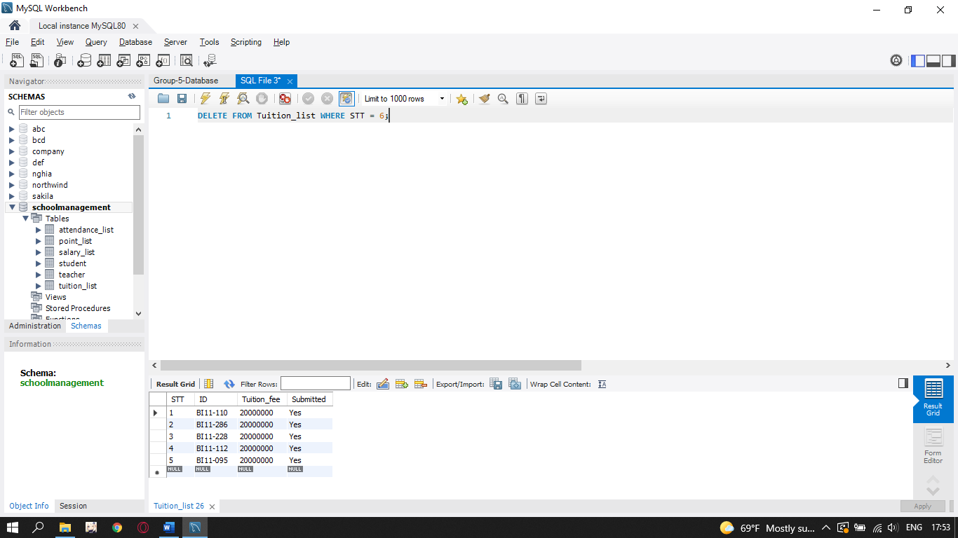

+ If we want to update data in table, we have an example: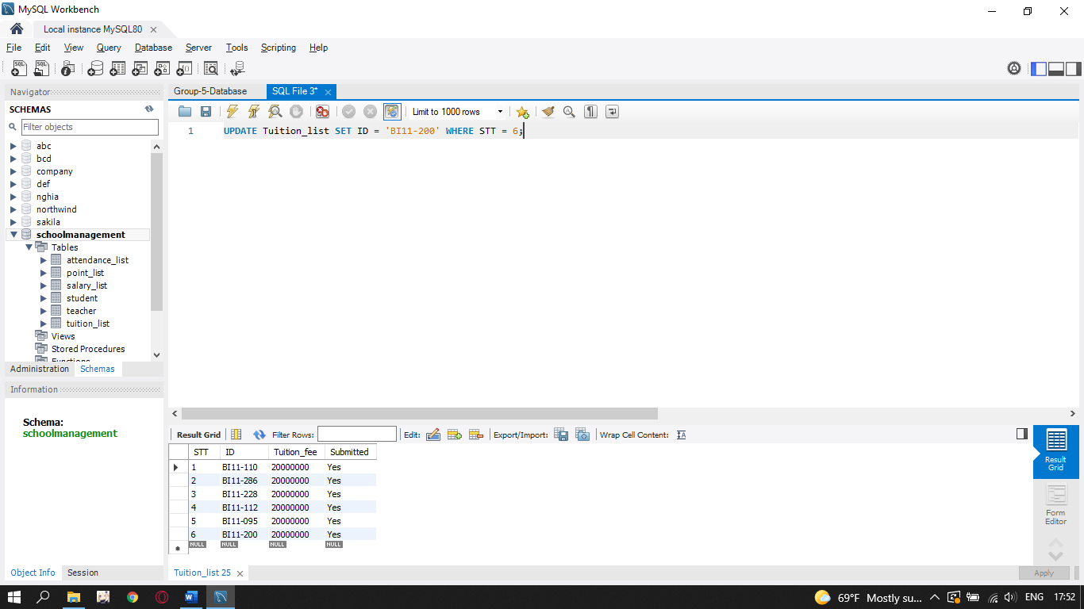

+ Order the data from the first to the last by:

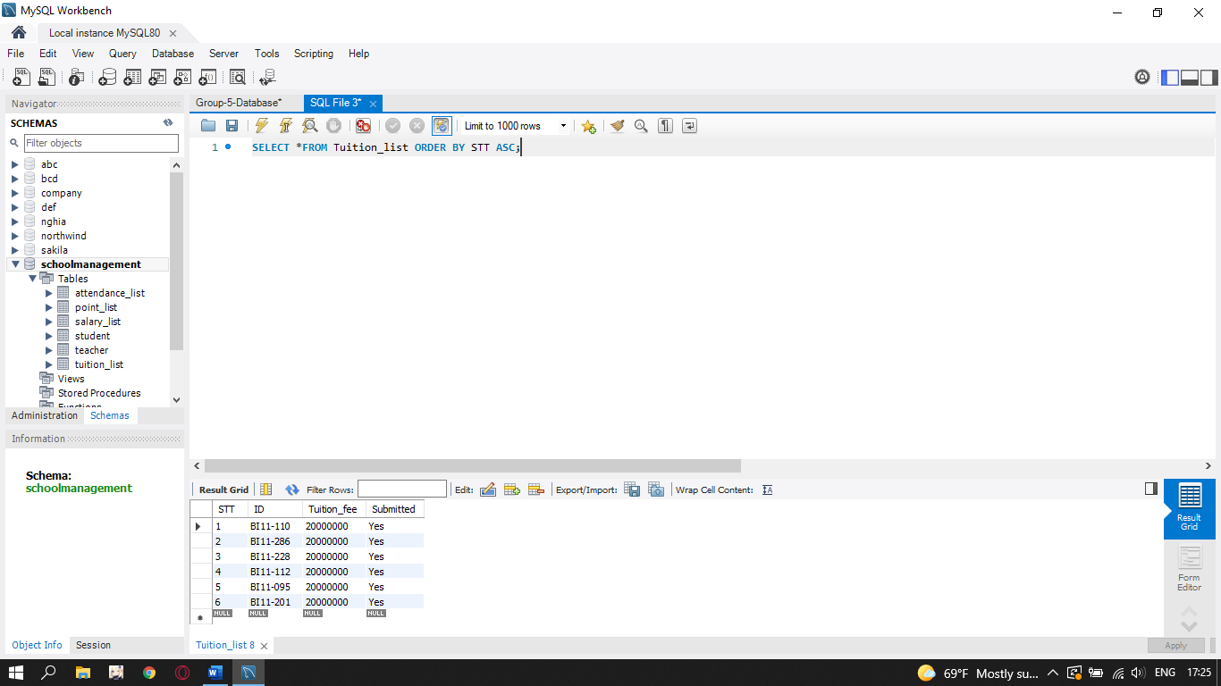

+Finally, we combine the attendance list with the students table: